Practice for Chapter 2

Follow the instructions below. After you are finished, save your file. Then, download the finished sample included in the website practice page, and compare the finished sample with what you did.

- Download the image of Ponta and the butterfly (pontafly.jpg) linked to on the same page where you got this file. Place the image somewhere it will be easy for you to find.
- Open PowerPoint 2016
- Choose to open a BLANK presentation
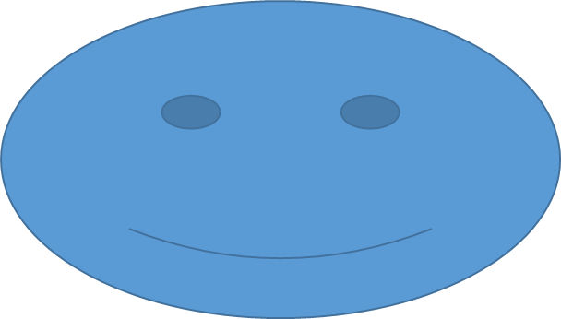
- In the HOME tab, in the SLIDES group, click on Layout, and choose BLANK
- In the INSERT tab, under ILLUSTRATIONS, click on SHAPES and select a SMILEY FACE. Click in the left side of the slide and drag to create a Smiley Face shape. Notice that you can make the face thin or fat. Make this one wide, as is shown to the right.
- Use the RESHAPE HANDLE on the face's mouth to create an UNHAPPY FACE.
- Choose a SMILEY FACE from the shapes again. This time, before you draw the face, HOLD DOWN the SHIFT KEY while you click and drag to draw the face. Notice that you cannot make it fat or thin—it is only a perfect circle. Make the face a perfect circle to the right of the first face.
- In the INSERT tab, under IMAGES, click on the PICTURES button. In the Insert Picture dialog box, navigate to where you saved the Ponta picture, then insert it.
- Resize the Ponta image so it is about 2/3rds the height of the slide. Center the image so it is in the middle of the slide, between the two Face shapes.
- In the INSERT tab, under the TEXT group, click on TEXT BOX. Create a text box under the unhappy face, and type "Unhappy!" ROTATE the text box so the right side tilts down.
- Create a second text box under the happy face, and type "Happy!" ROTATE the text box so the left side tilts down.
- Select both text boxes, then in the HOME tab, under FONT, make both text boxes use the Bodoni MT Black font, and set the size to 35pt.
- Also in the HOME tab, under FONT, change the color of the "Unhappy" text to Blue, and set the color of the "Happy" text to Orange.
- In the INSERT tab, under TEXT, insert a WORD ART. Choose the style in the middle of the top row. In the Word Art box, type "PONTA the SHIBA."
- Place the Word Art ABOVE the picture of Ponta.
- In the DRAWING TOOLS: FORMAT tab that appears when you click on the Word Art, under the WORDART STYLES group, click on the TEXT EFFECTS menu, and go into the TRANSFORM submenu at the bottom; choose the first selection under FOLLOW PATH, the one called ARCH UP. The word Art will become an arch; reposition the Word Art if it goes off the slide.
- RIGHT-CLICK on the Unhappy Face, and select FORMAT SHAPE from the bottom of the menu. In the FORMAT PANE at right, give the shape a GRADIENT fill.
- Under SHAPE EFFECTS, give the Unhappy Face a SHADOW which falls under the shape, and a medium blue GLOW.
- RIGHT-CLICK on the Happy Face, and give it a SOLID FILL; choose the color YELLOW. Change the LINE of the shape to RED and 5 pt WIDTH.
- Under SHAPE EFFECTS, give the Happy Face a REFLECTION, and under 3D FORMAT, give it a plain TOP BEZEL, with a WIDTH of 20 pt. In the same area, add a DEPTH of 20 pt. Do a 3D ROTATE so the face is looking up and to the left.
- Select the picture of Ponta. In the FORMAT pane, under EFFECTS, choose the final area, ARTISTIC EFFECTS. Choose the effect in the middle of the top row, PENCIL GRAYSCALE. Set the TRANSPARENCY to 50%, and the PENCIL SIZE to 10.
- Also in the FORMAT PICTURE pane, under the PICTURE tab/button, in PICTURE COLOR, choose a SATURATION of 200%.

Save the slideshow. Then download the finished example, and compare with what you created.

